Punch Accelerometer

This is a feedback and training device to help a boxer optimize punching force, reaction time, workout intensity, and endurance.

# Minimum Viable Product:

* Detect, record, and display g-force of a punch from the target

# Software Features for MVP

* Pattern recognition to detect straights/jabs, hooks, and uppercuts
* Bluetooth communication with computer or phone
* Call out punch force instead of displaying
* Audible prompt for punches
  + Measure reaction time after audible prompt

# Ultimate build – more hardware required

* Load cell could calibrate directly measured force (lbs) with acceleration of the target (g-force). This accomplishes 2 things: (1) gives you a real-world force measurement for punches (2) allows you to normalize readings from different targets (e.g. 70 lbs. heavy bag and BOB)
* Multiple accelerometers wired to one Arduino could select sensor with the highest force and use data to localize the punch (head/body)
* Connect heartrate strap and pace punches to match target HR zone
* Acceleration sensor on hands could add a lot of useful data:
  + Hand speed
  + Inefficiency - cocking arm before punching
  + Break out reaction time vs. time to target into separate measurements
* Pressure sensors in feet could correlate weight transfer to punching power
* Red light / green light prompts to mix in blocking and attacking
  + Challenge: this won’t measure avoiding punches (slipping/bobbing), only blocking
  + Red + green at the same time could prompt counterpunch, which would require boxer to reach target faster than usual
* Take video with forward-facing camera and sync to data feed
* Utilize built-in IMU to measure g-force to 16g, ADXL377 to measure from 16g to 200g

# Problems and ideas

* How to baseline power measurement? Use a load cell to compare directly measured force to force calculated from g-force detection.

<http://www.digikey.com/product-detail/en/te-connectivity-measurement-specialties/FC2311-0000-0500-L/MSP6953-ND/809399>

* Note that this has an output of 100mV, but the Arduino wants analog inputs of 3.3V. I think one of these amplifiers should solve the problem:

<http://www.robotshop.com/en/strain-gauge-load-cell-amplifier-shield-2ch.html?gclid=CNqAhNSPhc0CFZNhfgodKigMhQ>

<https://learn.sparkfun.com/tutorials/load-cell-amplifier-hx711-breakout-hookup-guide>

<https://learn.sparkfun.com/tutorials/getting-started-with-load-cells>

* 200g accelerometer to measure impacts over 16g limit of Curie:

<https://www.adafruit.com/products/1413?gclid=CISd382-_8wCFVNqfgodWAcAMg>

Ideally, you could employ both accelerometers, using the Curie built-in for acceleration up to 16g, and the ADXL for bigger hits

* Interesting sensor for cheap calibration, as well as to give accuracy points for landing a punch on the button: <https://www.sparkfun.com/products/8685>
* Nicely documented project with a 250g sensor:

<https://abieneman.wordpress.com/2010/04/04/punch-acceleration-sensor/>

* A different approach, but no useful code or parts list: <http://www.eetimes.com/document.asp?doc_id=1279578>

# Math

* Calculating energy from a pendulum:

<http://www.endmemo.com/physics/spendulum.php>

<http://www.wikihow.com/Calculate-Kinetic-Energy>

Maximum punch speed = 10m/s

Arm mass = 6 kg

Kinetic energy = 300J

Similar reference punch: 68lb weight dropped from ceiling on a 1m pendulum – or –

45 lb weight on a 1.5m pendulum –or-

34 lb weight on a 2.0m pendulum

# Related Products

* Puncho boxing glove (development prototype): <http://www.industrial-design-germany.com/innovations/intelligent-boxing-glove-puncho.html>
* StrikeTec – Really slick UI, but doubt this will ever ship: <http://efdsports.com/>

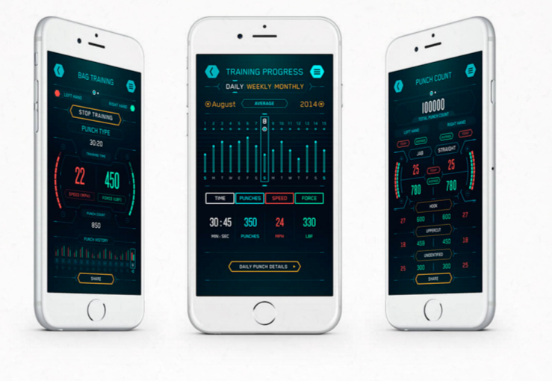

* Hysko – taking pre-orders for Sept 2016 ship date @ $129. 2017 price planned @ $219. Raised $120K from Y-Combinator and $80K from other investors. <https://www.hykso.com/>

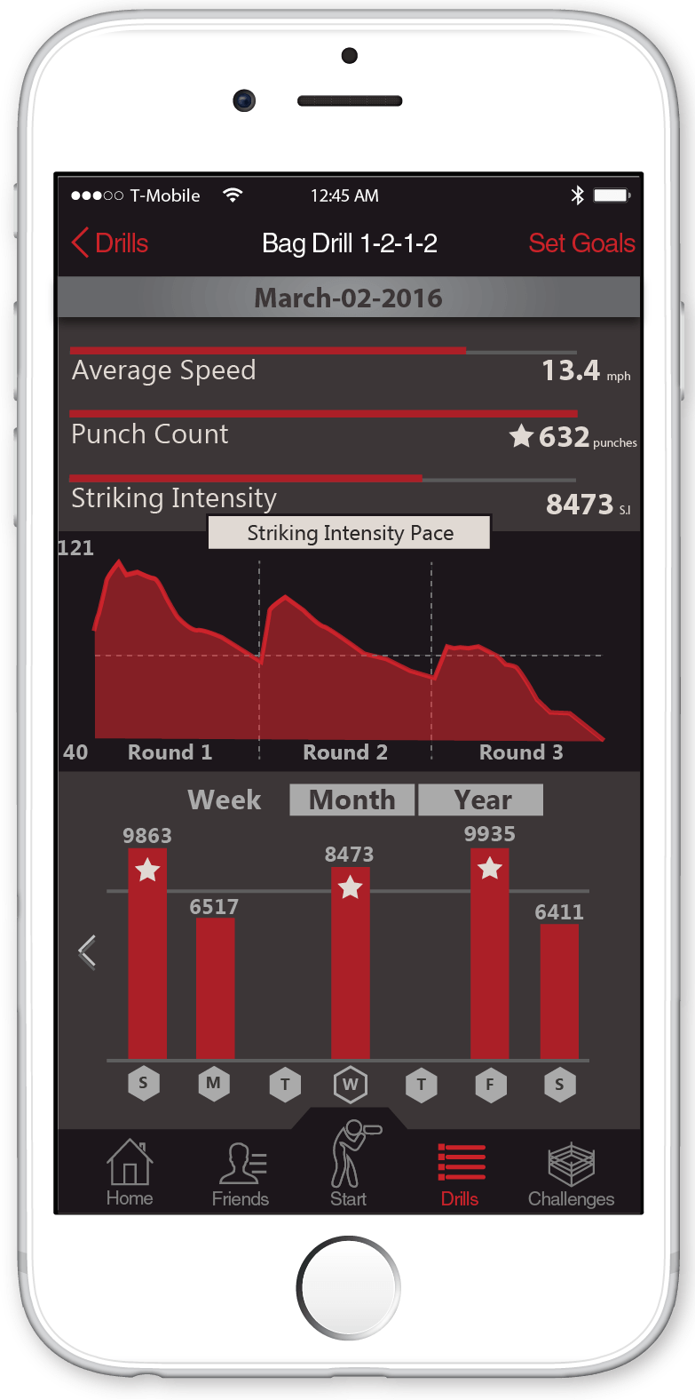 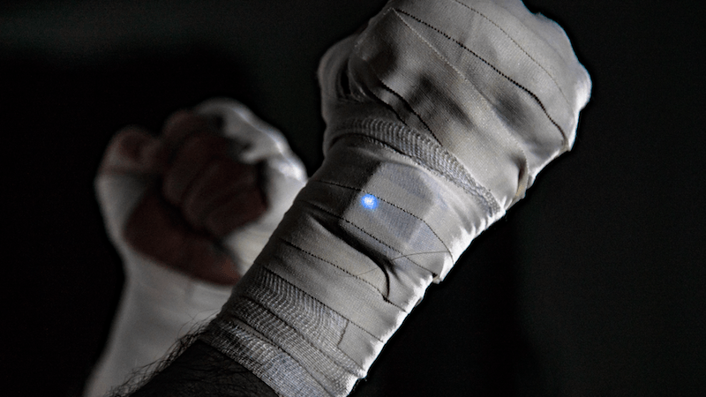

# Development Notes:

Goal: Detect, record, and display g-force of a punch from the target

5/30

* Detection working
* Display working and displaying g-force on a 3 axes
* Peak hold feature working – might want to make this a function
* Wrote Accelerometer-calibrate function to calibrate for starting orientation

Issues:

* Need to be able to factor out 1g gravity

CureIMU.setAcceleratorOffset() might fix this, but I couldn’t get it to work as I expected: <https://www.arduino.cc/en/Reference/CurieIMUsetAccelerometerOffset>

6/1

* Ordered load cell, amplifier, 200g accelerometer
* Added straight/uppercut/hook detection, but I’m not sure it’s working right

6/2

* Acceleration calculation verified

|  |  |  |  |  |  |
| --- | --- | --- | --- | --- | --- |
| **X** | **Y** | **Z** | **G-Calculated** | **G-Displayed** | **Punch Type** |
| 0.19 | 1.21 | 9.55 | 9.63 | 9.63 | S |
| 5.29 | 0.21 | 3.84 | 6.54 | 6.54 | H |
| 0.21 | 7.99 | 2.58 | 8.40 | 8.39 | U |
| 1.33 | 2.9 | 8.54 | 9.12 | 9.11 | S |
| 0.76 | 6.47 | 4.97 | 8.19 | 8.17 | U |
| 0.79 | 2.85 | 9.72 | 10.16 | 10.16 | S |

* Punch type detection working!



6/3

* Get Bluetooth working with this heartrate monitor sketch: <https://www.arduino.cc/en/Tutorial/Genuino101CurieBLEHeartRateMonitor>

6/4

* Set up Github repo
* Integrate GitHub repo w/Slack channel

Next steps:

* Display accelerometer readings from BLE: <http://www.forward.com.au/pfod/BLE/index.html>
* Test IMU calibration sketch: <https://www.arduino.cc/en/Tutorial/Genuino101CurieIMUOrientationVisualiser>
* Create a reference for generating kinetic energy: weight swinging from a pendulum to hit a load cell
* As a second test, place load cell on far side of bag and have it strike a hard surface. This should measure how much energy is lost to deformation/compression of punching bag
* Test this sketch to visualize orientation of punching bag in real time:

<https://www.arduino.cc/en/Tutorial/Genuino101CurieIMUOrientationVisualiser>